Coulomb’s law

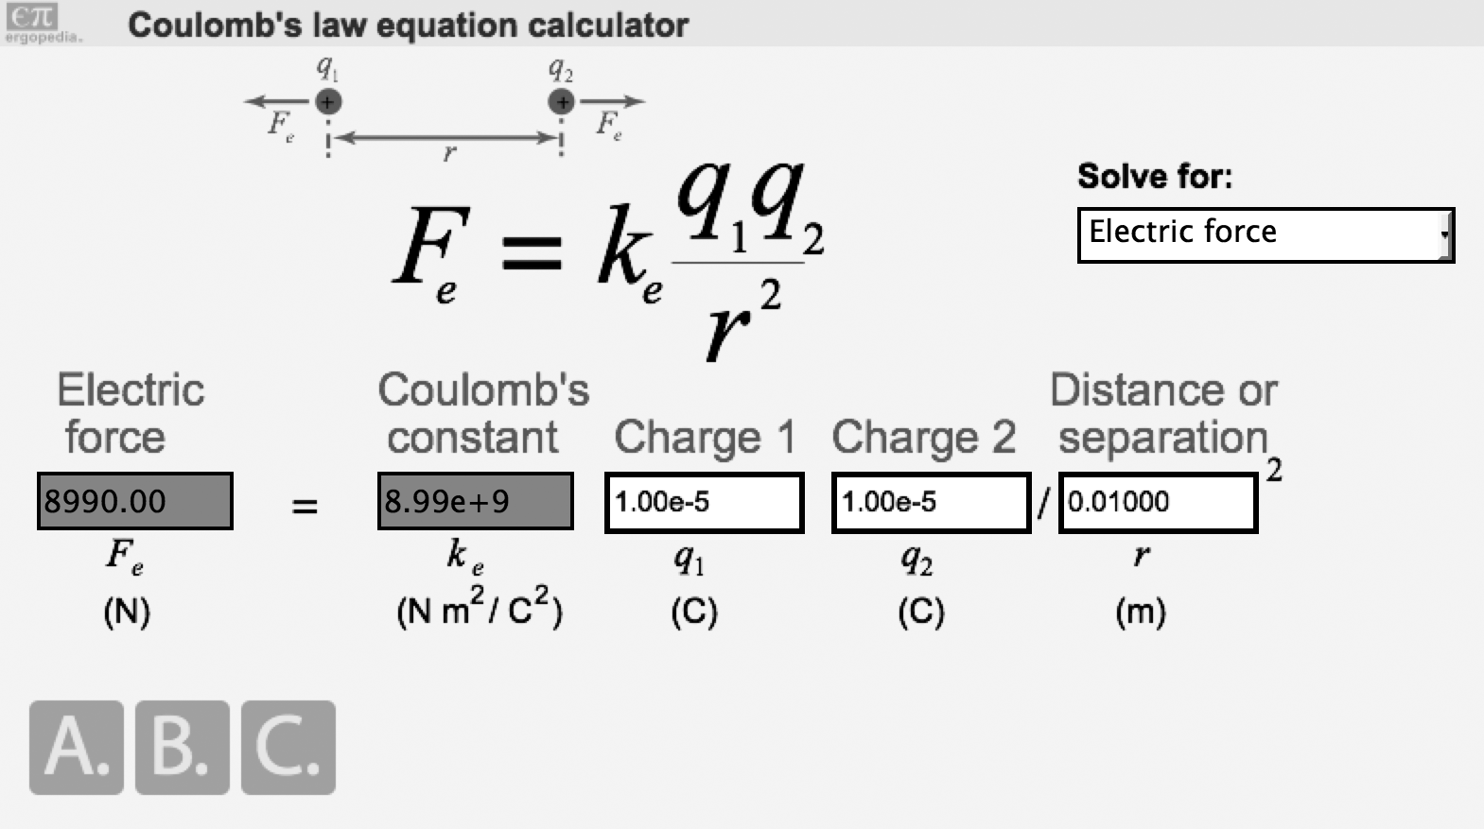

- Two charged objects are located 1.0 m apart.

  - Calculate the magnitude of the electric force between them if the two charges are +1.0 μC and +1.0 μC. (1.0 μC equals 1.0×10⁻⁶ C)

  - What would be the magnitude of the force if the charges were 0.5 meters apart?

- Two insulating spheres with charges of -7.0 μC and -12 μC, are located 10.0 centimeters apart.

  - What is the force between them?

  - What direction does it act?

- How close must two 1.0 C charged objects be for their mutual force to exceed 1.0 newton? Compare that distance to something in your everyday life.

- Two identical point charges are separated by 0.50 m. If the force between them is 8.0 N, what is the magnitude of each charge?

- Three charged particles are arranged as shown along the x-axis. The central charge Q has a value of +10 μC. Charge q_{A} has a value of +5.0 μC and is 1.0 m to the left of Q. Charge q_{B} is 2.0 m to the right of Q.

q_{A} = +5.0 μC Q = +10 μC q_{B} = ?
v

v

v

1.0 m 2.0 m

- The net force on charge Q is zero. What is the value of q_{B} (magnitude and sign)?

- If the value of charge Q is doubled, how does that change your answer to part a?

