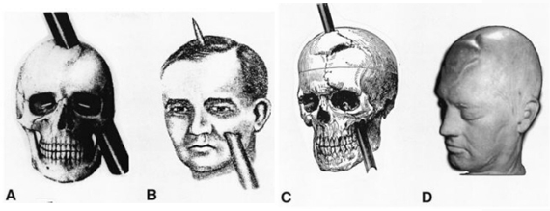
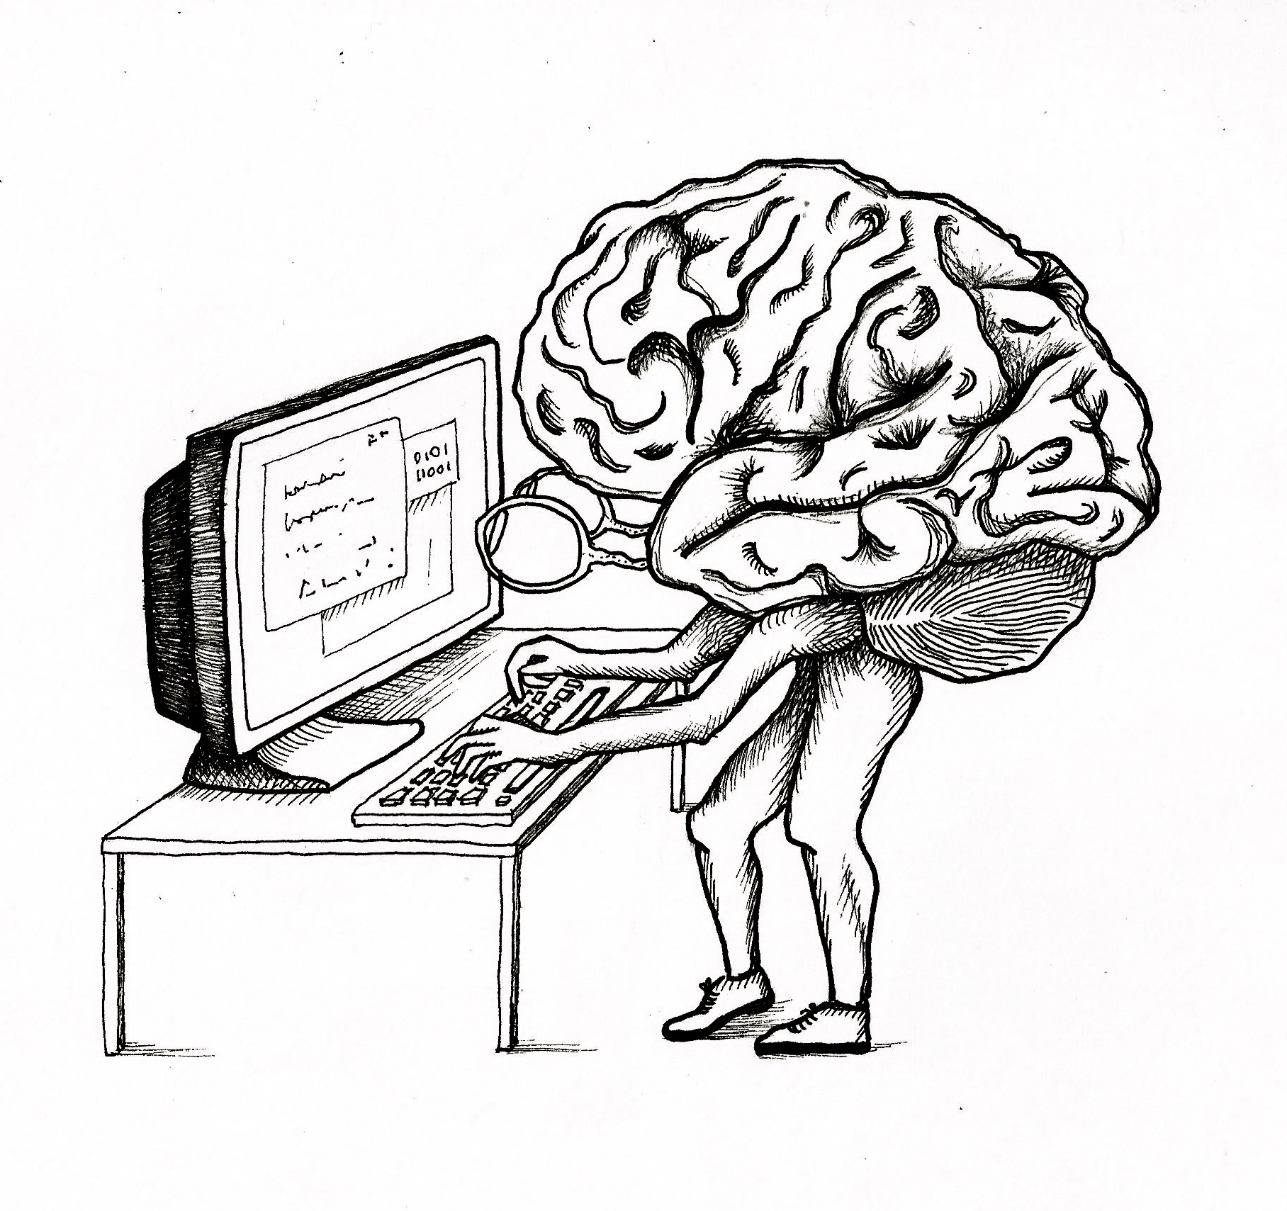
Studying the Brain

The brain is something we are constantly learning more and more about and we have just scratched the surface. Psychologists have many ways to study the brain and their method will depend on what they are trying to research and find out more about. Each of the following methods have been used throughout psychological history. For each of the follow ways to study the brain, complete the task(s) and become an expert in each technique!

Method #1…Accidents

Find (and watch) a video of Phineas Gage and his infamous accident. Copy and past the link to the video:

Summarize the video in 1-3 sentences. | HOW does the case of Phineas Gage illustrate the function of the frontal lobe?

Method #2…Electroencephalogram (say that three times fast)
Abbreviation: | Find a picture online showing this method and insert it here:
Describe the method:

What do psychologists usually use this method to study? |  | HIGHLIGHT what this method studies about the brain:  STRUCTURES FUNCTIONS

Method #3…CT Scan
What does it stand for? (what is the full name):  Also know as: | Find a picture online showing this method and insert it here:
Describe the method:
What do psychologists usually use this method to study?
Create a mnemonic (or memory trick) to help you remember this method and what it studies: |  | HIGHLIGHT what this method studies about the brain:  STRUCTURES FUNCTIONS

Method #4…Positron Emission Tomography
Abbreviation: |  | Find a picture online showing an image of the brain from this method and insert it here:
Describe the method:
What do psychologists usually use this method to study?
HIGHLIGHT what this method studies about the brain:  STRUCTURES FUNCTIONS | What is used in this method that the other methods do not use? WHY is this used?

Methods #4 & #5…MRI & fMRI
Side By Side Comparison
MRI Stands for: | fMRI Stands for:
Describe the MRI Method: | Describe the fMRI Method:
Insert a picture of an MRI of a brain: | Insert a picture of a fMRI of a brain:
Psychologists use an MRI to study… | Psychologists use a fMRI to study…
HIGHLIGHT what this method studies about the brain:  STRUCTURES FUNCTIONS | HIGHLIGHT what this method studies about the brain:  STRUCTURES FUNCTIONS

